Techno Machine Tools

Survey no:126/A/1, DOOR NO: 4-132-9/A/2, Gandimaisamma X Road,

Medchal Malkajgeri,Hyderabad-500043.Telangana, India.

(Machine tool manufacturers)

T.SIVARAMAKRISHNA
ME. MBA.,
---------------------------------------------------------------------------------------------------------------------------------------------

TMT/RBN Steel/S094/2025 07.03.2025

To,
Shahid F
Company : RBN Steel
Mobile No :+919830088381
City : Pune
State : 'Maharashtra'

Dear sir,

Sub :- Supply of 2550 MM Wide And 2- 8 MM Cut-To- Length Machine

We thank you for your enquiry regarding cut to length machine with 2550mm wide and thickness 8.0 mm. We are glad to inform you that we would be in a position to do the required equipment as per the following specifications and descriptions of the machine along with our terms and conditions.

MANDREL UNCOILER

Capacity : 10 Ton

Model : Single Arm

Mandrel movement : Hydraulic

Back Tension : Caliper brake,
Manually adjusted

Coil hold down : Hydraulic

Construction : M. S. Fabricated.

Drive : 10 HP along with

SHEET LEVELING

PINCHROLL

Number of pinch rollers : 2 Nos

Diameter of the roll : dia 180 mm

Load arrangement for pinch rolls : manual wheel

LEVELER

Type of the machine : 4Hi

Maximum sheet width that can be leveled : 2550 MM

Maximum sheet thickness in MS that can be leveled : 8.0 MM

Minimum sheet thickness in MS that can be leveled : 2 MM

Roll dia : 140 mm

No of work rolls : 9 Nos

No of back up rolls : 55 Nos

Speed of the machine : 0-10 meters/min

Model : Crossed Beam

Drive : 80 HP – AC motor

The lever is with triangular roll attachment along with hydraulic screw down along with differential load indication.. The pinch roll is allowed the strip to move to forward to entry guides.

2550 MM WIDE SHEAR ING UNIT

Maximum sheet width that can be sheared : 5550 MM

Maximum sheet thickness in MS that can be sheared : 8 MM

Minimum sheet thickness in MS that can be leveled : 2 MM

No of strokes per minuet : 14

Bed width : 550 mm

Power pack : 20 HP

PRICE

The price of Cut-to-length machine along with power pack and complete package
Rs 1,24,00,000/- ( Rupees One crore twenty four lakhs only)

GENERAL TERMS & CONDITIONS:

- Price quoted per unit ex-work. Hyderabad.
- Following charges are additional to your account.
- Freight Charge : As actual to be borne by you.
- Sales Tax : Extra @ 18% .
- Packing charge : As actual to be borne by you.
- Insurance : As actual to be borne by you.
- Payment : 50% advance along with order balance 50%before delivery but after inspection at our works.
- Delivery : with in 8 weeks from date of advance received
- Validity : One month from the date of submission.
- Inspection : Inspection at our works prior to dispatch.
- Warranty : The machine is warranted for a period of 12 months from the date of dispatch against any manufacturing defects/ faulty material or bad workmanship of any part or component but not against any kind of abnormal or improper use of machine. Defective part or component will be replaced or repaired free of cost. Electrical components are outside the scope of this warranty.
- Commissioning : Erection & commissioning done by you, but required technical support & guidance provide by us at additional cost.

NOTE:

- Oil is not in our scope of supply.
- Raw material for trial is to be arranged by you at your cost.

We are sure you will find our offer in line with your requirements. Please contact 9246221106 for further information / clarifications required if any.

Thanking you and assuring you of our best services.

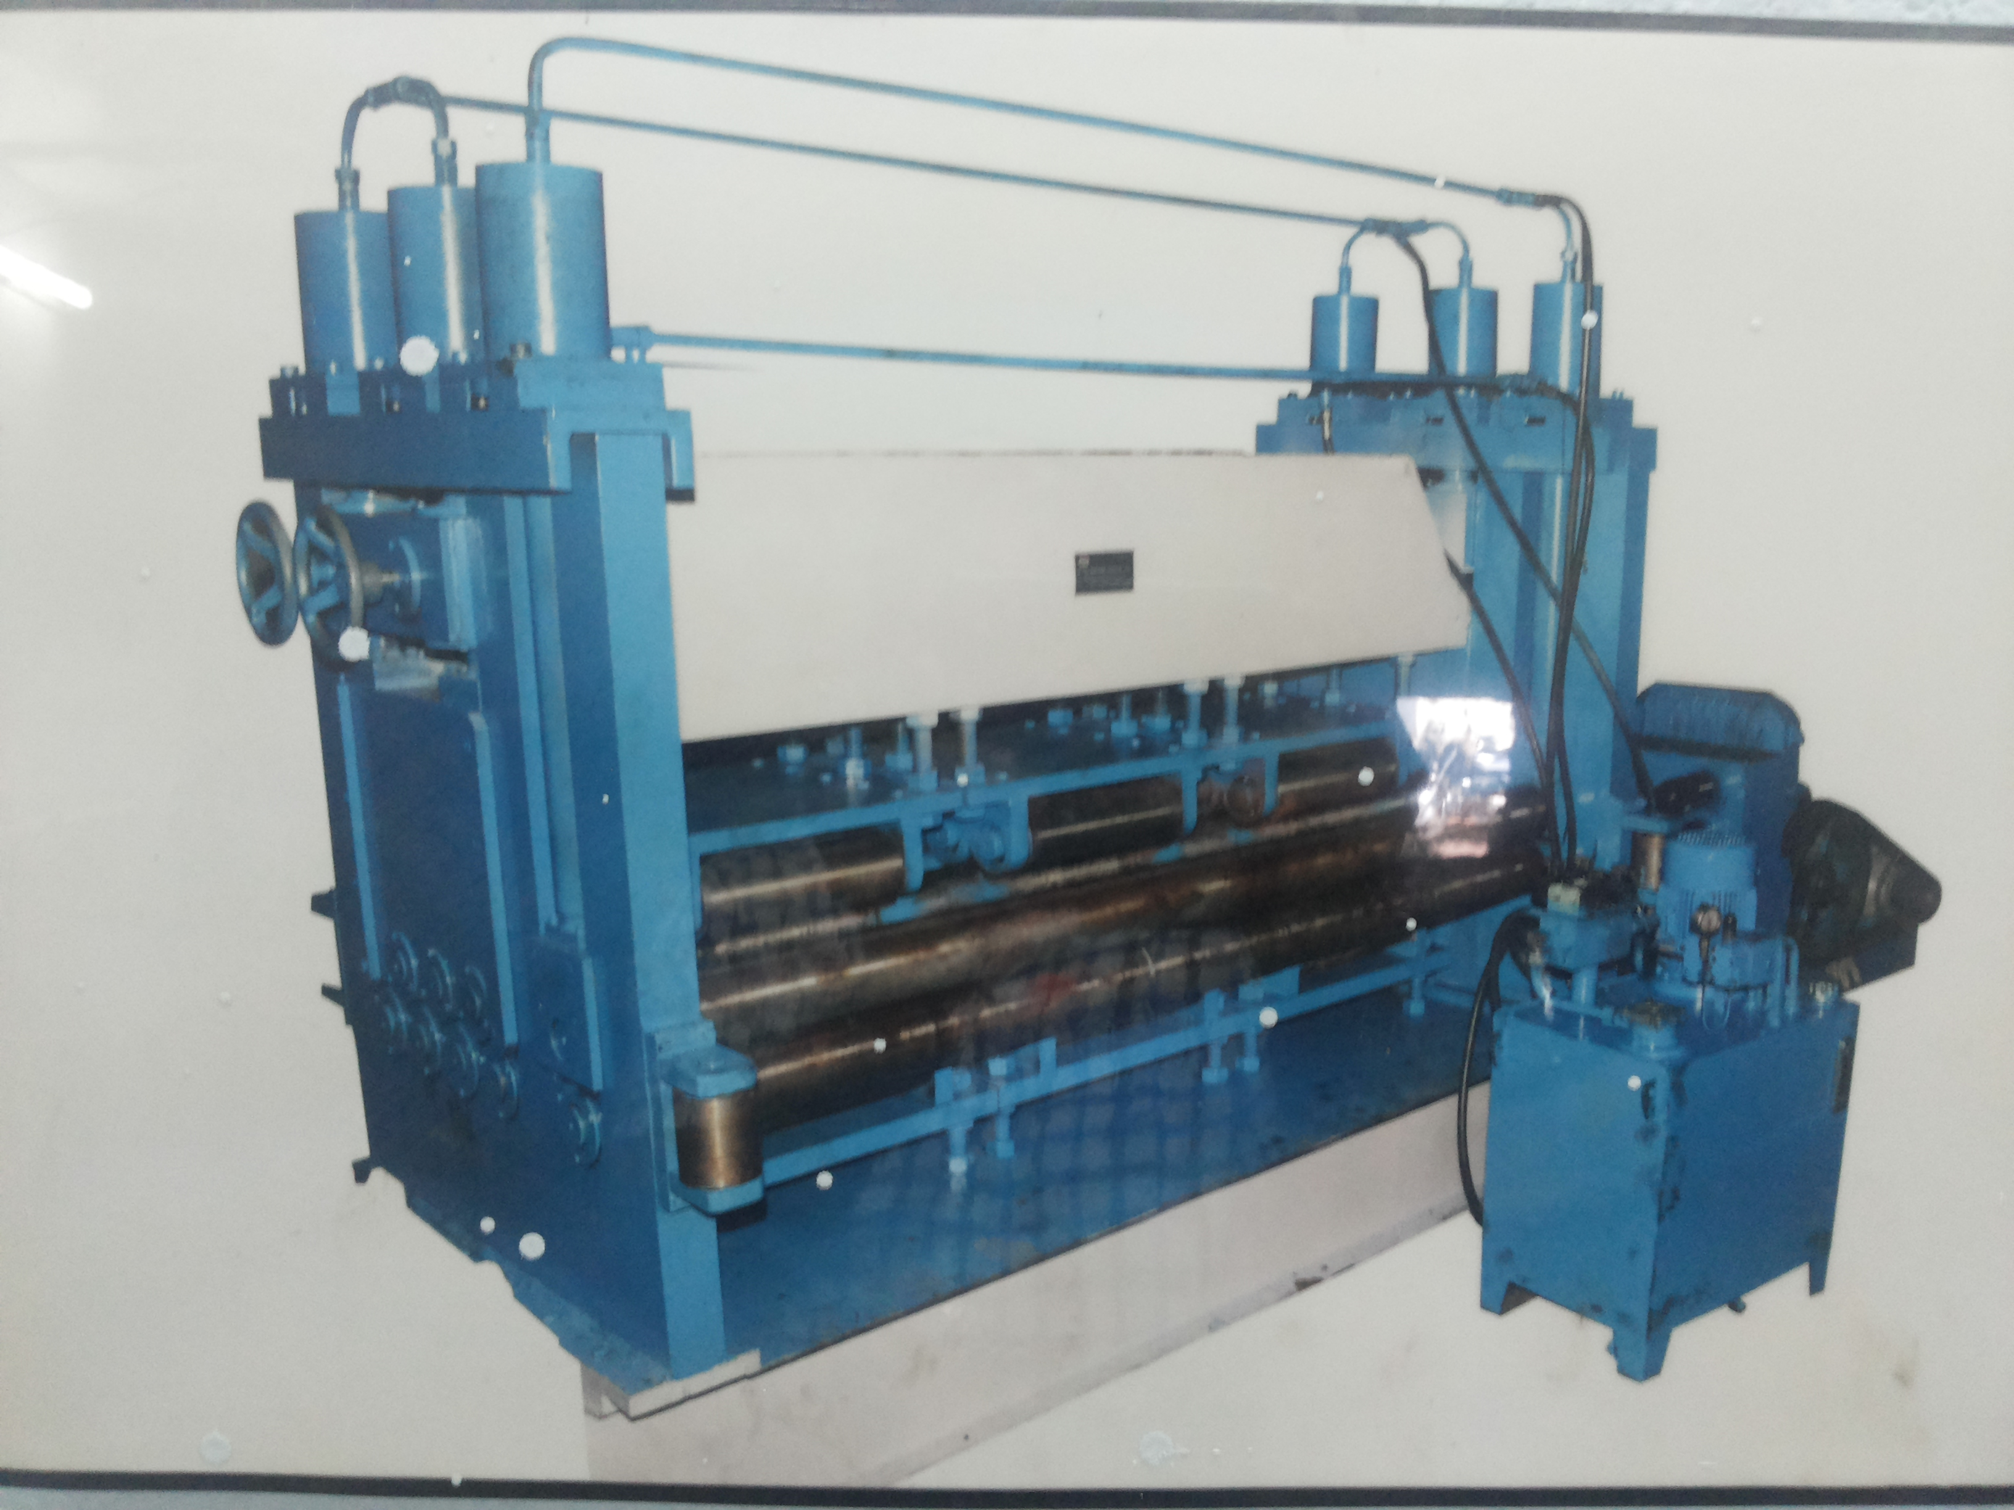

For TECHNO MACHINE TOOLS

( T. SIVARAMAKRISHNA)

